Spatial Frequency Theory

This theory suggests that out visual system is an Fourrier filter, and the sensory primitives are sinusoidal gratings, or more precisely, Gabor functions.

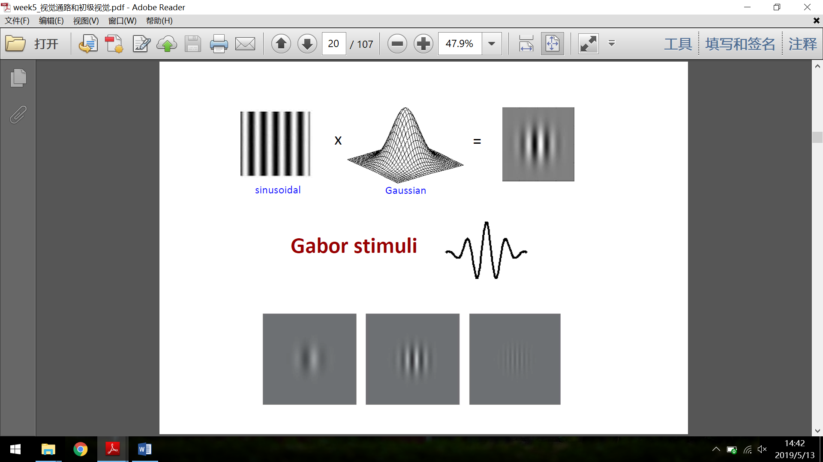

Psychological evidence

Contrast sensitivity function: the difference threshold for contrast under different spatial frequency. And it it suggested that there are multiple spatial frequecy “channels” (tuning curves) in the visual system, which is called the spatial frequency channels theory.

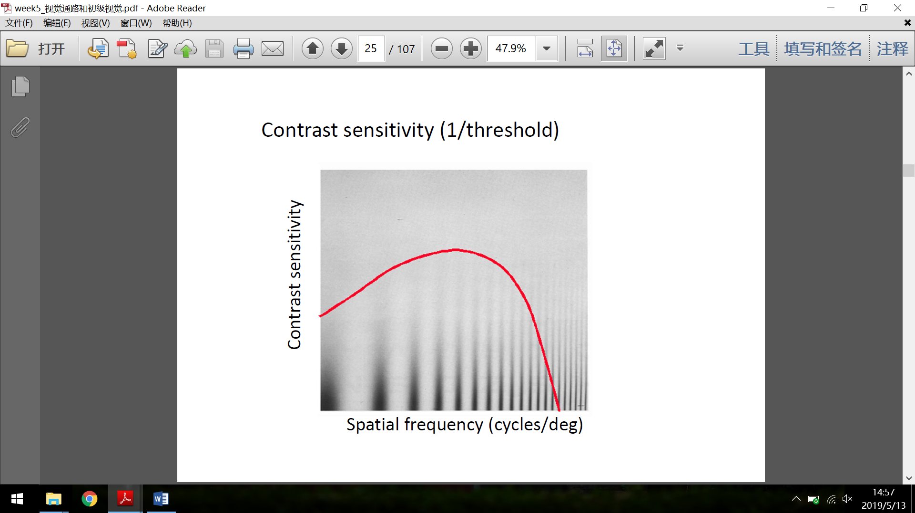 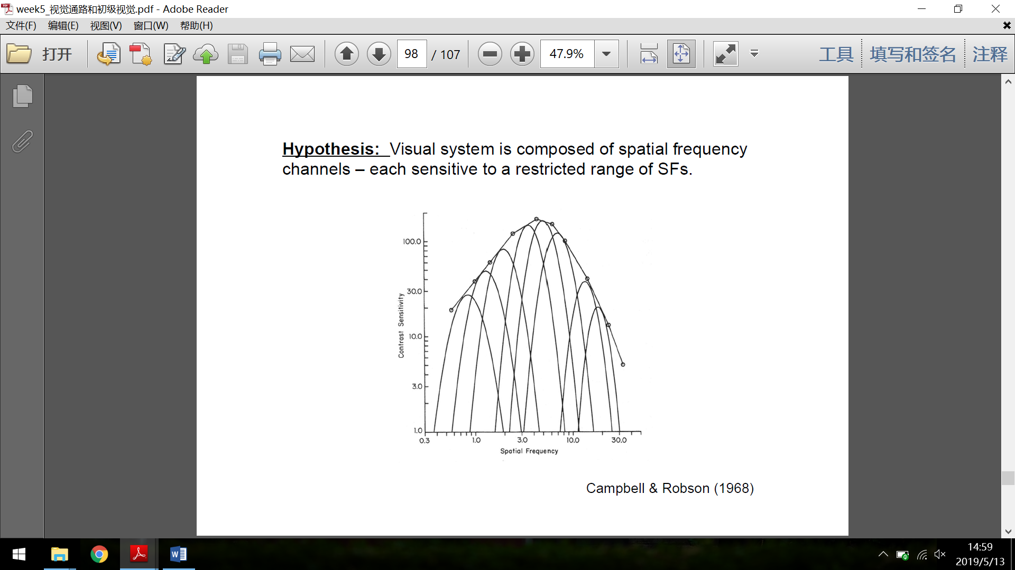

Evidence from selected adaptation:

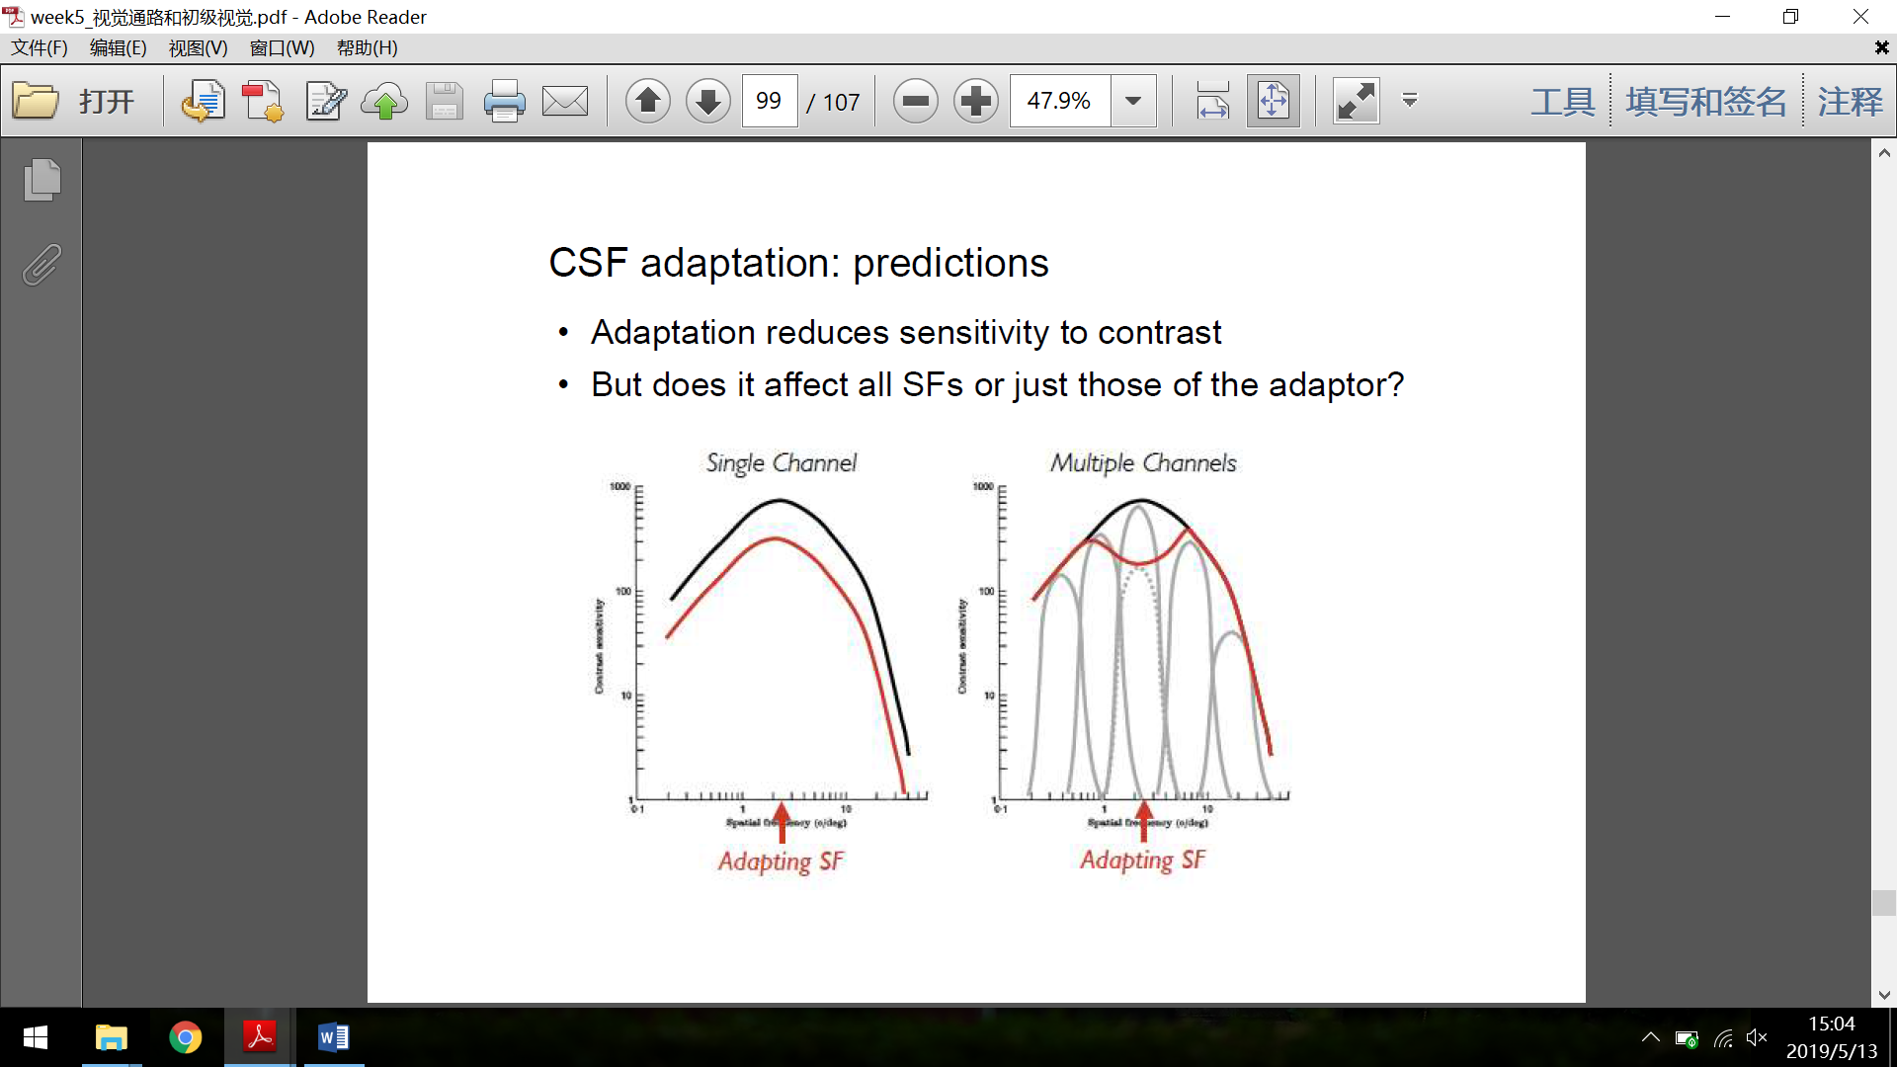 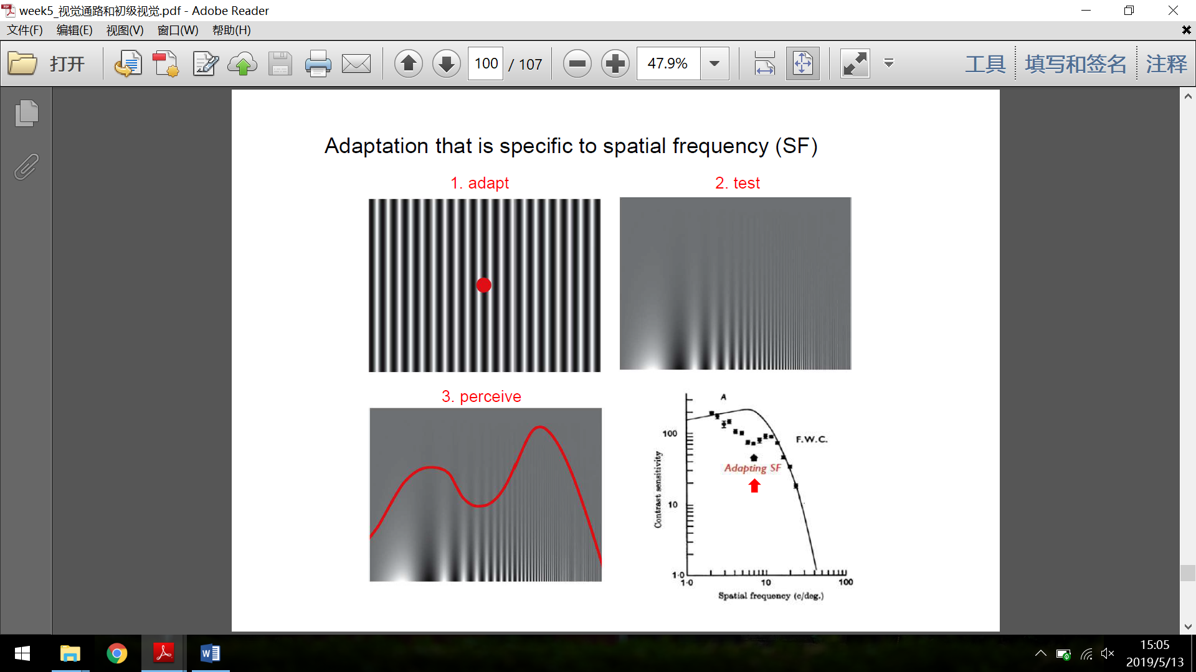

For tiltness:



Evidence revealed by masking: detect a sinusoidal stimulus under a grating mask and see how the perceptual threshold for contrast changes.

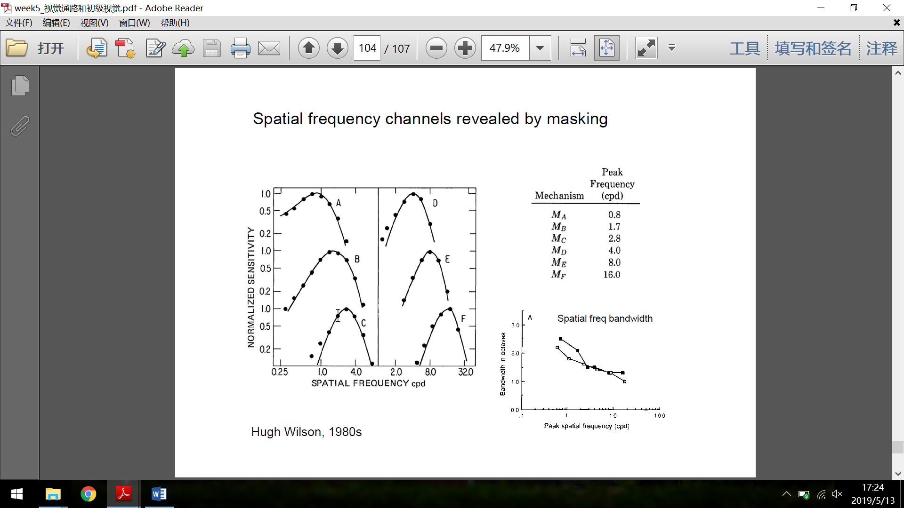

Evidence from aftereffects: adaptation of spatial frequency and orientation.

Development of frequency channels: for infants and extended blindness patients, the CSF significantly moves down and leftward; for elderly people there is also a mild effect. And it is illustrated that the visual system retains plasticity even for adults, because patients’ CSF is significantly improved after treatment.

Physiological evidence

As is mentioned in the Neural Pathway section, neurons in the straite cortex can act as spatial frequency analyzers. And the function column organization is closely relavant to the process of spatial frequency.

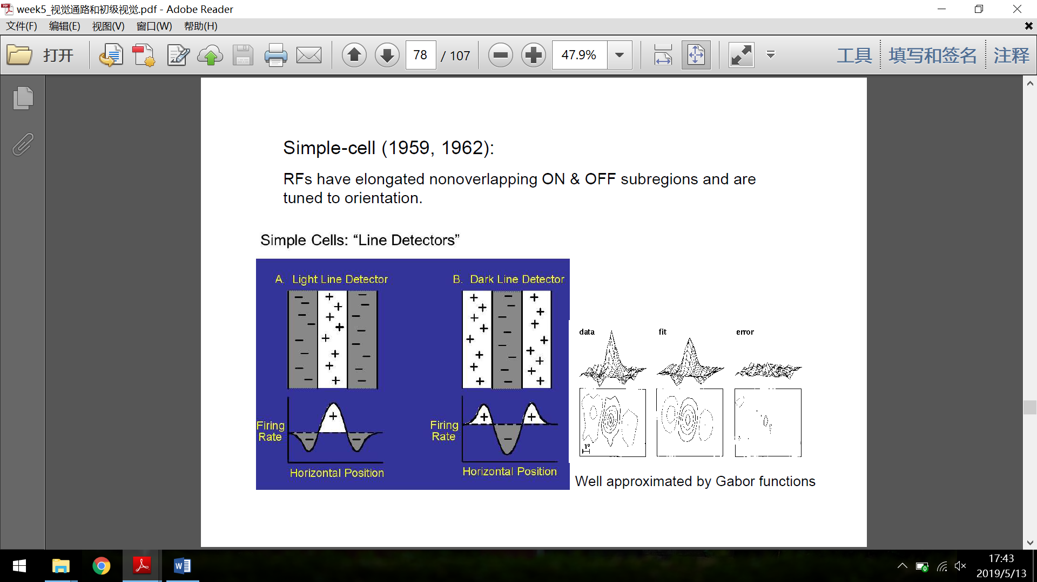 

Feature detection theory

RGC and LGN level: center-surround receptive field

 

V1 simple cells: edge detectors

V1 complex cells: motion detectors

V1 hypercomplex cells: end detectors

 

 

Compututational approach

Marr’s primal sketches

David Marr divided the process of what psychologists call “primary vision” into two processes: grey-scale image – raw primal sketch – full primal sketch.

The raw primal sketch contains the information about naturalistic features in the picture, such as lines, edges, blobs, terminators or so. And the full primal sketch connects the short segments together, and groups similar elements together.

Recent researches indicate that this process may happen later than Marr suggested, because the output of the primary stage (and V1) is only some dots that should be on a line, but not the line itself. Actually the line must be generated by connecting these dots, using a top-down (e.g. baysian estimation) or bottom-up (e.g. nearest neighbour) strategy.

Edge detection

Similar to the center-surround receptive field of the visual neurons, we can use a particular convolution operator to scan the image. It turns out that the edges stand out in the computed picture.

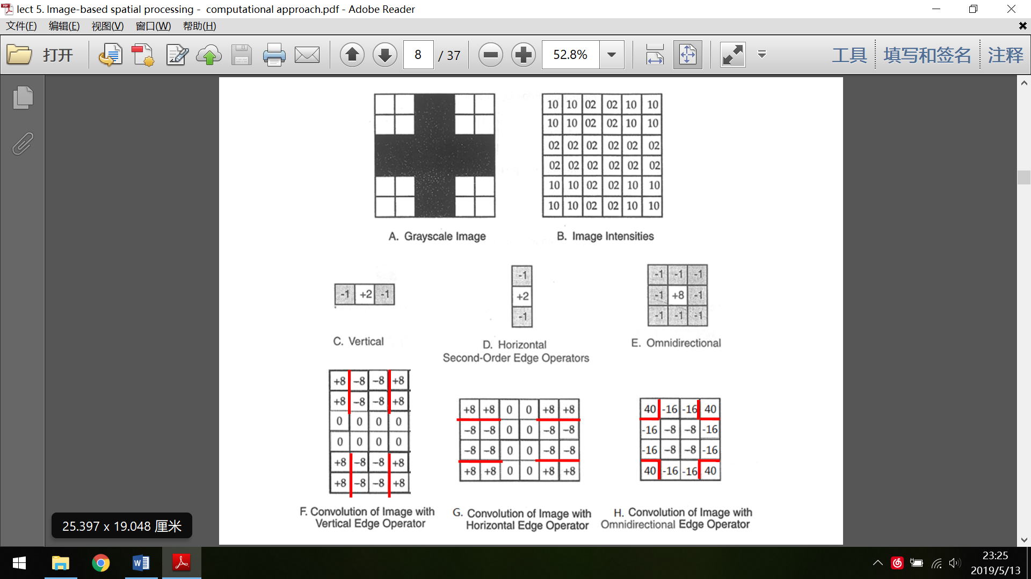 

The algorithm can be interpreted as a way to use differentiate operator to find out the zero-crossing of the second derivative of the luminance. By using this omidirectional operator, we can detect the edge in any orientation simultaneously. A possible implementation is illustrated below:



Problem about the scale

In order to detect the features of different size, we need to analyze with different resolutions. In order to find out the “real” edges (not those trivial ones, like those caused by shading), we must determine how the different edges at different scales match up. There’s an algorithm called Witkin’s scale integration.

Spatial frequency filter theory

This theory suggests that V1 only performs the basic frequency analysis that can determine the change in luminance, but the “real” edge detector (as mentioned before) is at the higher level.



Encoding of the natural images

Since all natural images (256 \* 256 grey-scale) generate a subset of all possible images, it’s reasonable to assume that they follow a certain distribution if encoded in some way. And there are mainly two ways for encoding, the compact one and the sparse one.

Compact coding: Principle Component Analysis (PCA), which can reduce the dimension of the data, only keep those ones with most significant variance. However, the eigenvectors computed from natural images seems not correspondent to the receptive field of the neurons (they are grid-like, actually).

Sparse coding: using larger number of channels to encode but only few of them give a non-zero output. An example is the Independent Component Analysis (ICA). And the eigenvectors generated look very similar to Gabor functions. Sparse coding is actually the foundation of CNN.